Tushar Balarajan  
CSC 200 (036N)  
Professor Shaban  
Programming Assignment #1

**Problem Statement:**

Pick some positive integer and call it n.

If n is even, divide it by two.

If n is odd, multiply it by three and add one.

Continue this process until n is equal to on

**Source Code:**

package hailstone;

import java.util.Scanner;

/*@author Tushar Balarajan*/

public class Hailstone {

public static void main(String[] args) {

Scanner kybd = new Scanner(System.in);

System.out.println("\n Enter a positive number");

int number = kybd.nextInt();

int oddnumber;

int evennumber;

while ( number !=1){

while (number %2 !=0){

oddnumber = 3 * number + 1;

System.out.println( number + "\t is odd, so I make 3n+1:\t" + oddnumber);

number = oddnumber;

}

evennumber = number /2;

System.out.println(number + "\t is even, so I take half:\t" + evennumber);

number = evennumber;

}

}

}

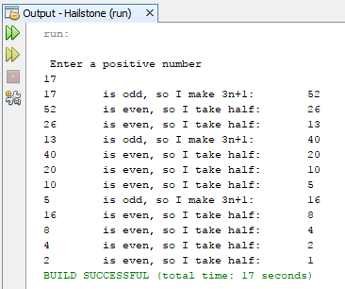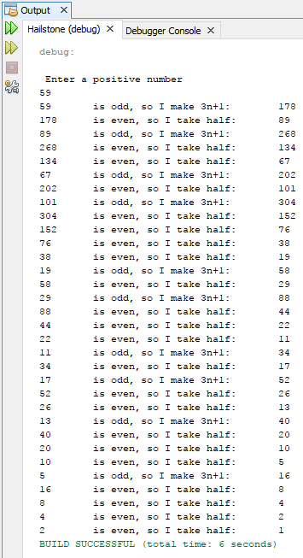**Output:**

